* Ctrl+C agr terminal kahien stuck ho ay tu dubara -> lany ka liay terminal pr
* Ctrl+B sa vs code ma File explorer navbar open close hota ha

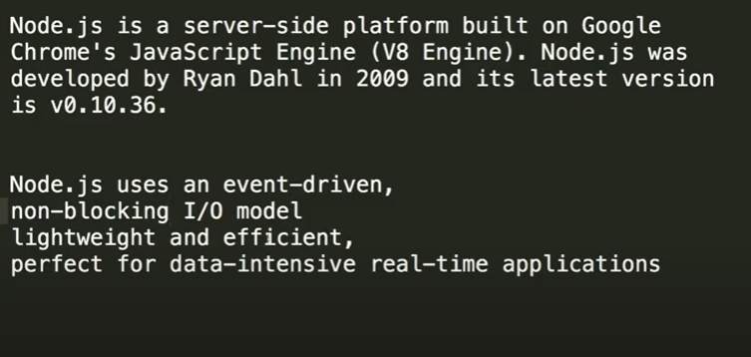

Nodejs non blocking I/O model ka mtlb jaisy dusri languages ma ha msln php ma jb hum kisi data ki request krty hain tu usky regarding ek queue bnti jati ha ka jo pehly aya wo fullfill ho ga lekin nodejs ma aisa nahi hota. server hamari request bhejta ha aur jis bhi request ka pehly result fetch kr lia gya tu bs wo return kr di jay gi yani aisa nahi hota ka request1,request2,reuest3,request4 aii tu ab server queue ma pehly 1 ko fulfill complete kry aur jb tk fullfill na ho tu server bakion ko execute na kry. Blky node js ma tamam requests pr kam kia jata ha at a time aur jo bhi request ka result pehly feth kr lia jay task complete ho jay tu usko return kr dia jata ha.

**What is the role of package manager?**

A package manager keeps track of what software is installed on your computer, allowing you to easily install new software, upgrade software to newer versions, or remove software you previously installed.

Package manager ka andr msln kafi ziada banaya howa code hota ha aur hamain just us package ko download krna prta ha aur usky andr different codes ma sa apna desired install kr skty hain ab us code ko dependencies keh skty hain hum msln Npm ek package manager ha aur usky andr buht sary classes codes/modules/packages msln digital clock ka code para howa ha tu ab us code ko dependency kehty hain yani package manager ka andr different packages/dependencies hum download krky use kr skty hain.

**NPM**

npm is the world's largest Software Registry. The registry contains over 800,000 code packages. Open-source developers use npm to share software. Many organizations also use npm to manage private development.

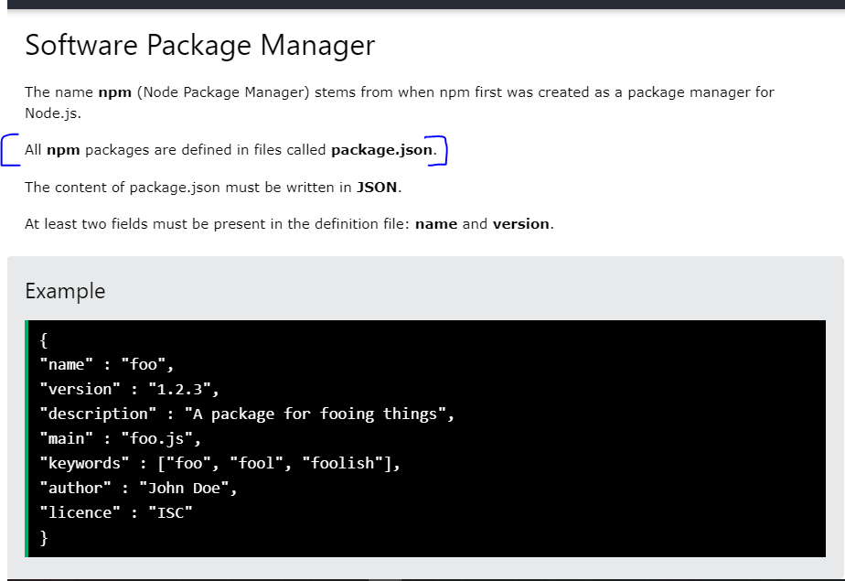

Hum jo bhi dependencies insall krty hain npm ka through wo package.json file ka andr dependencies {} ka andr a jati hain aur unka version bhi.

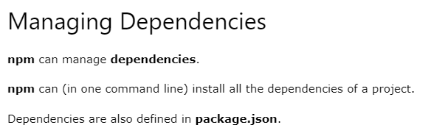

node is a framework that can run JavaScript code on your machine while npm is a package manager. Using npm we can install and remove javascript packages also known as node modules.

**Project Create**

Humain pehly npm ko initialize krna prta ha jisky liay hamain cmd pr **npm init** likhna ho ga jisy package.json file ban jay gi jismy sari dependencies hon gi version ka sath yani humain jo bhi dependencies require hongi wo is file ma hon gi.aur jb hum npm init krain ga tu phr hamain kuch require info deni ho gi jaisy main file ka nam starting point aur isi trha file nam etc.

**Require global object**

Hum ek file ka code dusry file ma use kr skty using export aur require msln

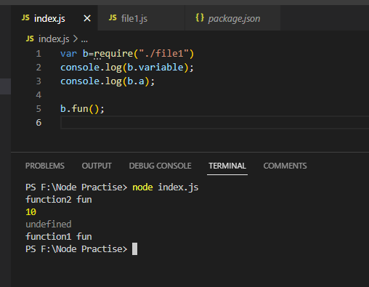

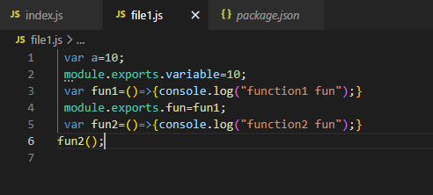

Alternatively, we can simply do 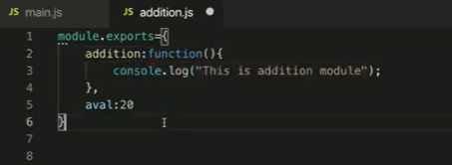

Humain ek file ka content dusri file ma use krny ka liay pehly us file1 ka content ko export krna prta ha aur hum require krty wqt ek variable ma store krwa lety phr usi variable object sa file1 ka content access krty.

Hum ye jo functions bana kr inko export kr rahy hain hum inko modules keh skty hain ka hum modules export import kr rahy hain kinky ek file ma module bana kr export krky dusri file ma require sa wo file import krky ek object ma store krny ka bad us object ka through hum us file ka andr ka variables/functions etc access call kr rhy.

**Prototype**

<https://www.tutorialsteacher.com/javascript/prototype-in-javascript#:~:text=The%20prototype%20is%20an%20object,aka%20attribute)%20is%20not%20visible>.

**What to do if we want to add new properties at later stage to a function which will be shared across all the instances?**

The answer is **Prototype**.

The prototype is an object that is associated with every functions and objects by default in JavaScript, where the function's prototype property is accessible and modifiable and object's prototype property (aka attribute) is not visible.Every function includes prototype object by default.

Yani msln humny koi function bana dia aur hum usmy kuch properties mazed add krna chahty lekin usky andr nhi likhna chahty aur chahty hain ka us function ka tamam instances us property ko access krain tu hum ye kr skty using Prototype object jo by default tamam functions ka andr mojod hota ha.

**Node.js HTTP Module**

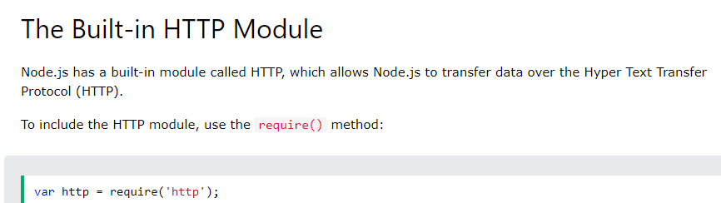

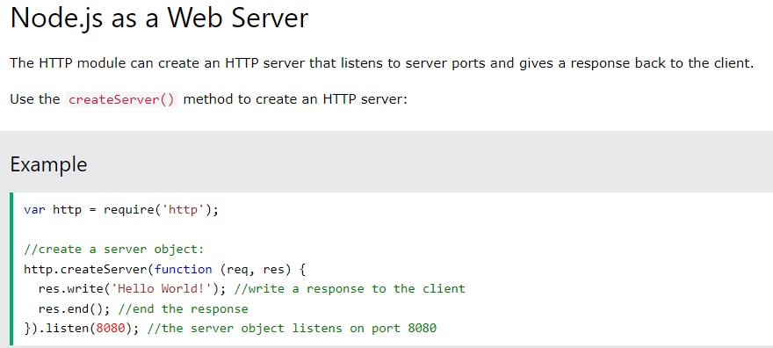

The function passed into the http.createServer() method, will be executed when someone tries to access the computer on port 8080.

Output :



Hum http module import krty hain taky iski inner functionalities ko use kr sakain.

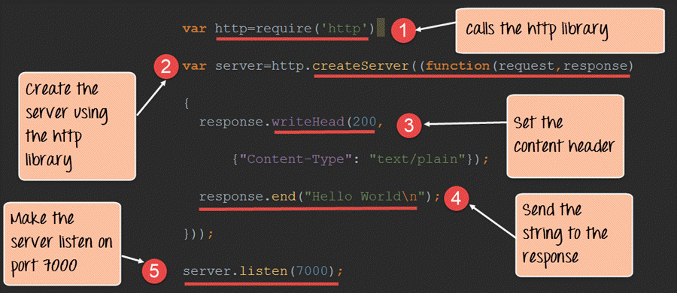

Jaisy php ma local host banany ka liay hamain pehly xamp on krky phr brower ma https:/localhost/port aisy krna prta tha lekin yehi server nodejs ma banay ka liay humain http module ka use krna prta ha.Hum console ma hi nahi blky browser ma bhi dekh sakain results is liay hum server create krty hain aur usky liay hum http module use krty hain.Header ma humny jo browser ka auper content show ho ga uski type batai ha msln agr humny plain text type di ha tu jo local server create ho ga uspr plaintext hi ho ga even humny <h1>hello</h1> bhi likha ho lekin agr humny content type header ma html da di tu html tags work krain ga

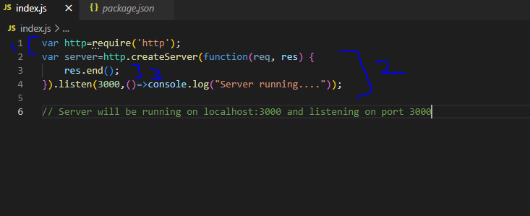

Humny server banana ha is liay humain http module ki zarort pry gi aur humny http module import kr lia.Ab humny server banaya jismy humny function pass kra aur ismy response.end() likhna zarori ha kionky ek ending point hona zarori ha wrna browsing hoti jay gi aur circle ghomta rahy ga.Listen ma hum port number dety hain jis port ka auper hum apni application ko run krwana chahty hain.

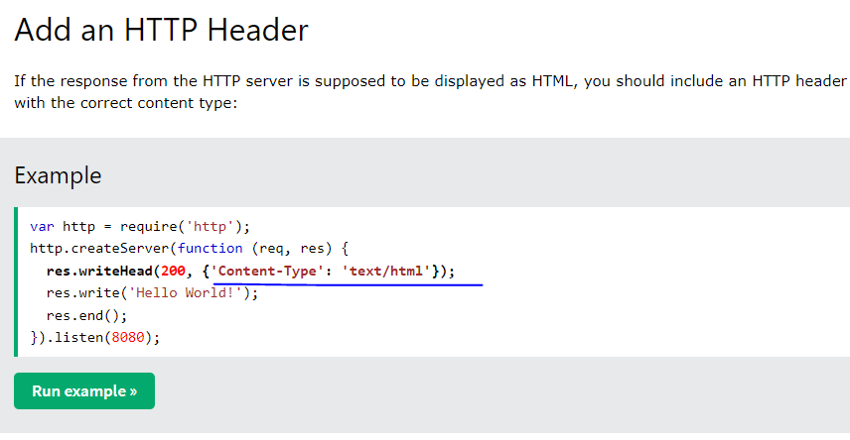

200 ka mtlb ha status ok.Hum header ma content type likh skty hain msln agr content type humny text/html likh dia tu hum agr res.write(“<h1>hello</h1>”); likhain tu html bhi work kry gi lekin agr hum content type text/plain likh dain tu hamain browser ma bhi <h1>hello</h1> aisy hi show ho ga instead of hello kionky humny content type ma plain text acceptable likha ha.

# Nodemon Installation

nodemon is a tool that helps develop Node. js based applications by automatically restarting the node application when file changes in the directory are detected. nodemon does not require any additional changes to your code or method of development.

Yani hum file ka andr kuch likhty hain phr file run krty hain output dikhi ab humny file ma dubara kuch content likha aur dubara node filename on terminal likha aur run kia ye ek tedious task ha iski bajay hum nodemon use krty hain jiski help sa humain bas save ctrl+s hi krna ha aur server khud hi bar bar restart ho jay ga.Isky liay hamain pehly nodemon package ko install krna ho ga aur cmd pr

npm install -g nodemon likhna ho ga. Ismy -g ka mtlb ha ka hum is package ko globally install kr rahay hain yani specific kisi project ka liay nahi blky all current aur in future waly projects files etc sbky liay hamain bar bar ye package install krna nhi pry ga ye globally install ho ga.

**To run :**

Type nodemon filename

i.e nodemon index

au risky bad bs file ma koi bhi change kkry just ctrl+s hi krna ha aur server khud hi restart hota jay ga jb bhi koi changes krky ctrl+s kia jay gat u

Note : If you face this error 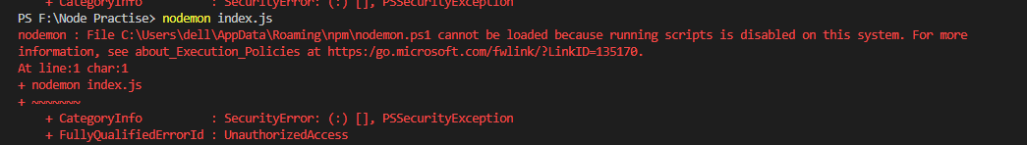

Then solution is on <https://stackoverflow.com/questions/63423584/how-to-fix-error-nodemon-ps1-cannot-be-loaded-because-running-scripts-is-disabl>

# File System Module in node.js

Hum file handling ka liay fs module use krty hain.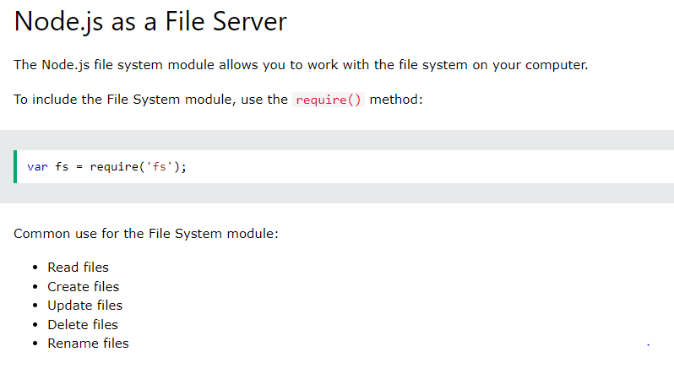

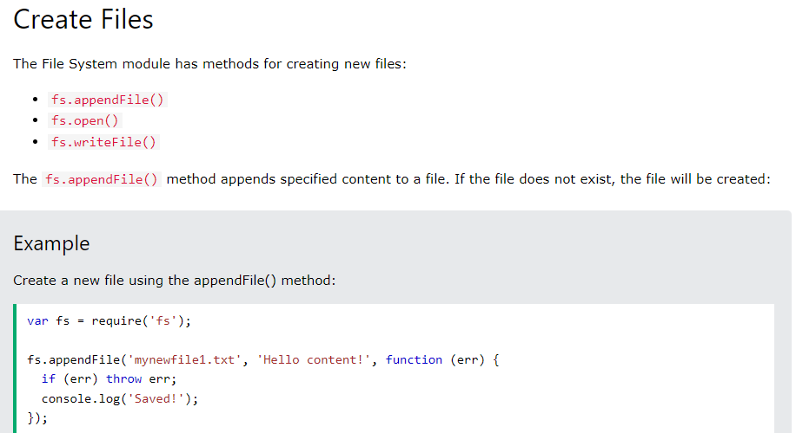

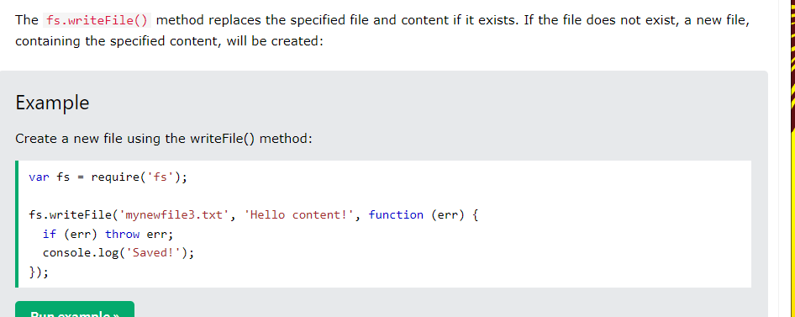

+++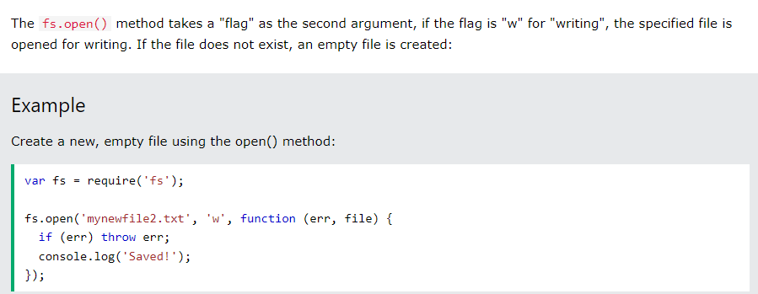

**Sync and Async function in file system**

Asynchronous functions are generally preferred over synchronous functions as they do not block the execution of the program whereas synchronous functions block the execution of the program until it has finished processing. Some of the asynchronous methods of fs module in NodeJS are: fs. readFile()

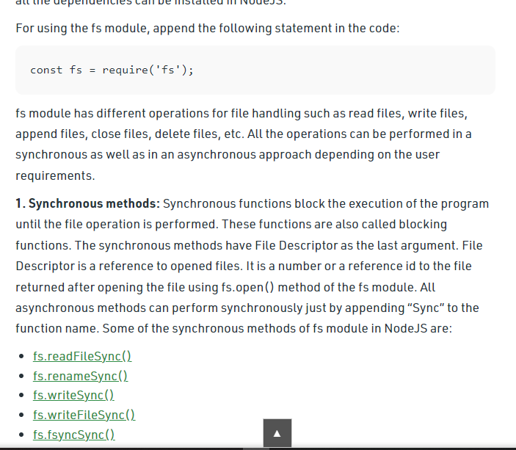

Jb asynchronously function hum use krty tu jb usy agla code agr less time ma execute ho sky tu wo execute hota aur wapis us point pr ata jahan tha pehly.

Synchronously ma msln program flow chal raha aur ek point pr humny msln data fetch kr rahy server say ya kisi aur file sat tu us line pr time lag raha ha tu jitna time lgy ga tb tk program agy execute nhi ho ga agla aur jb wo line complete execute ho jay gi flow of control of program resume ho ga aur then dubara sa program remain rest code execute ho ga.

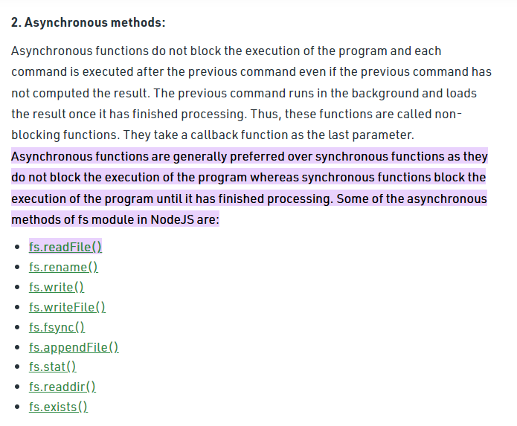

Synchronous functions ma hum mostly try catch use krty hain aur inmy hamain call back function bhi return ma nahi milta.~~Node js ma by default asynchronously working hoti ha.~~

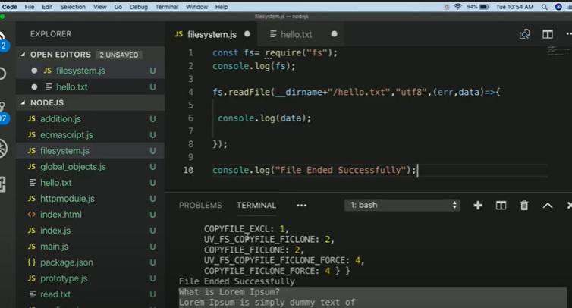

Figure 1Asynchronous function

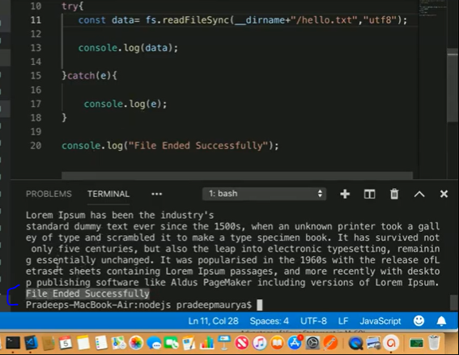

Figure 2Synchronous Function

# Create and Trigger Custom Event

Node. js allows us to create and handle custom events easily by using events module. Event module includes EventEmitter class which can be used to raise and handle custom events. Msln hum javascript ma krty thy ka onclick() event yani is button pr click ho tu ye function call ho usi trha custom events hum nodejs ma bana skty hain using event emitter aur un event ko call krny ka liay hamain trigger yani event ko emit krna prta ha.

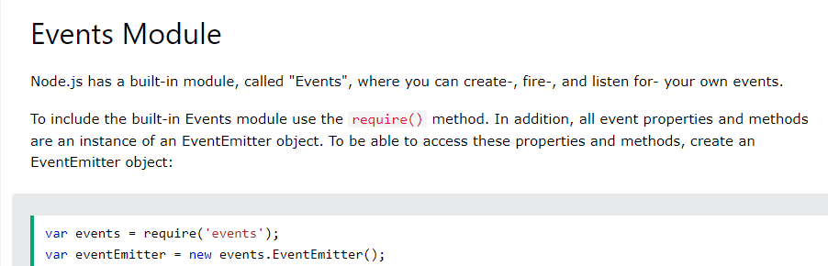

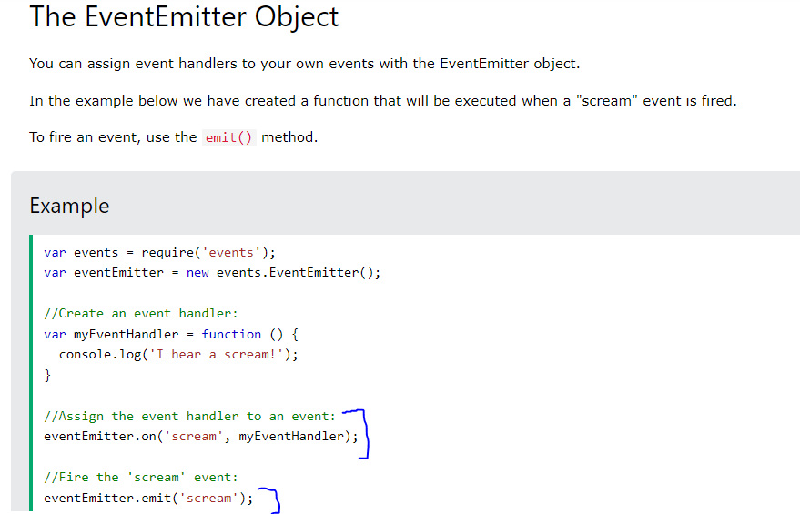

Hm scream ki jagha kuh aur bhi likh skty hain.

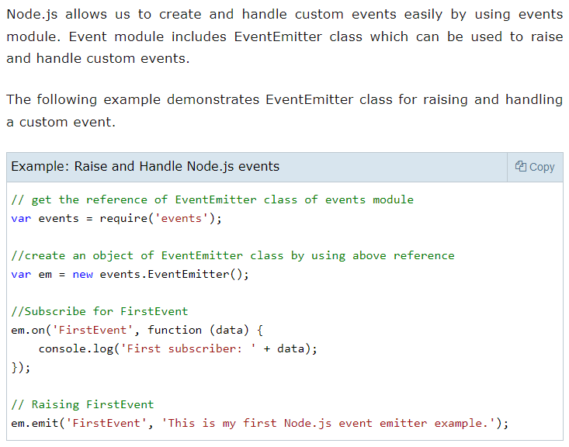

In the above example, we first import the 'events' module and then create an object of EventEmitter class. We then specify event handler function using on() function. The on() method requires name of the event to handle and callback function which is called when an event is raised.

The emit() function raises the specified event. First parameter is name of the event as a string and then arguments. An event can be emitted with zero or more arguments. You can specify any name for a custom event in the emit() function.

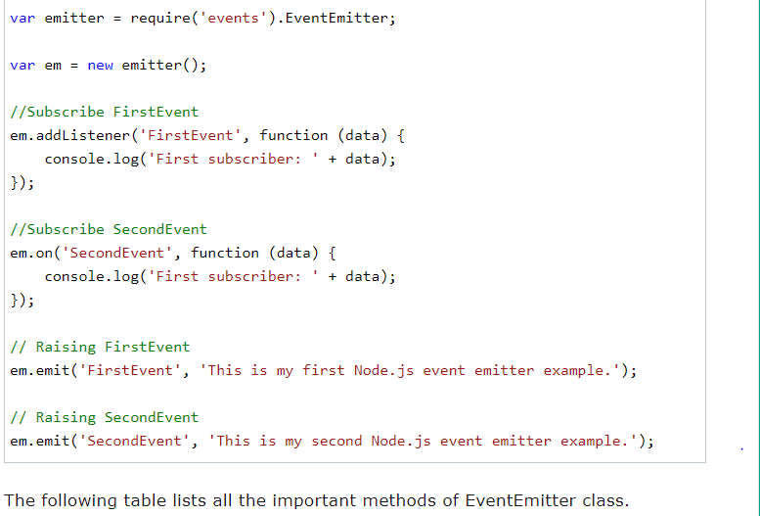

Figure Humny event trigger/call/emit krty wqt ek string as an argument bheja jo ka addListener() ma humny receive kia aur wo string data variable ma store ho gai.

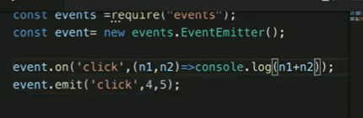

Figure Hum ek sa ziada arguments bhi bhej skty hain

Note: Hum ek event ka andr dusra event call kr skty msln

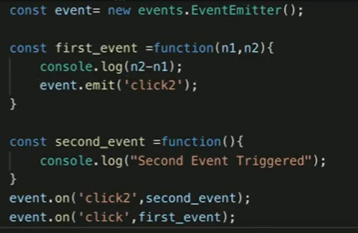

ab agr hum event.emit(‘click’,4,5) krain tu output ma shw ho ga:



# What is express js?

Iski help sa hamara line of code kam ho jay ga.

Express is a node js web application framework that provides broad features for building web and mobile applications. It is used to build a single page, multipage, and hybrid web application. It's a layer built on top of the Node js that helps manage servers and routes. Express.js, or simply Express, is a back-end web application framework for Node.js, released as free and open-source software under the MIT License. It is designed for building web applications and APIs. It has been called the de facto standard server framework for Node.js

<https://www.freecodecamp.org/news/going-out-to-eat-and-understanding-the-basics-of-express-js-f034a029fb66/>

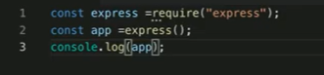

Line1: humny require krky import kr lia express ko aur ek object express ma store krwa lia

Line2: Ab express variable object ma jitney bhi methods thy humny wo sary app variable ka andr store krwa liay aur ab hum app object ki help sa express module ka andr mojod tamam functionalities functions etc access kr skty hain.

Line3:app ka andr jitney bhi methods hain unky name print ho jaien ga

Yani ab express ka andr kisi bhi method functionality ko use krny ka liay hamain app ko use krna pry ga.

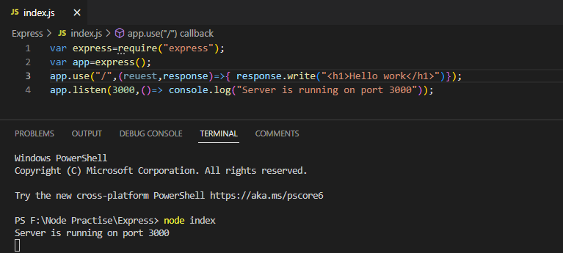

Figure use ki jagha get ana ha

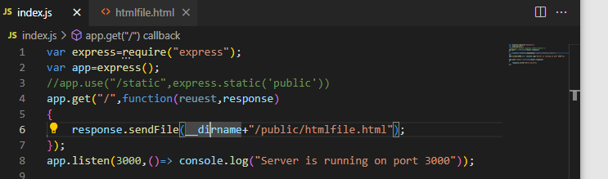

Line4:agr url ye ho tu usky regarding response ma ye dia jay jo {} ka andr likha.Is line ma basically hum page render kr rahy hain

App.listen() ma humny server create ka bataya ha ka is port ka auper server run kro.

Output:



# Express Template Engine

A **template engine** enables you to use static template files in your application**. At runtime, the template engine replaces variables in a template file with actual values, and transforms the template into an HTML file sent to the client.(msln hum ejs agr templae engine use kr rahay hain tu hum html code ka drmian body tag ka anr likhty hain <%= variable %> aur runtime ka wqt is variable ka andr jo value pri ho gi wo yahan place ho jay gi.)** This approach makes it easier to design an HTML page. **A template engine is a tool that enables developers to write HTML markup using plain JavaScript.** The template engine has its own defined syntax or tags that will either insert variables or run some programming logic at run time and generate final HTML before sending it to the browser for display.

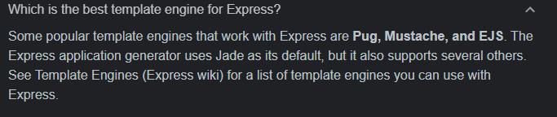

In sb Template engines ma difference yehi ha ka html likhny ka tareka

**Pub Template Engine Syntax**



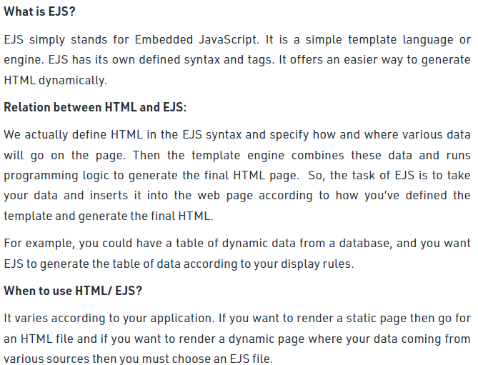

Create an ***index.ejs***file and put it in the ***views*** folder with the following code.Hum html coding ma dynamic code likh skty

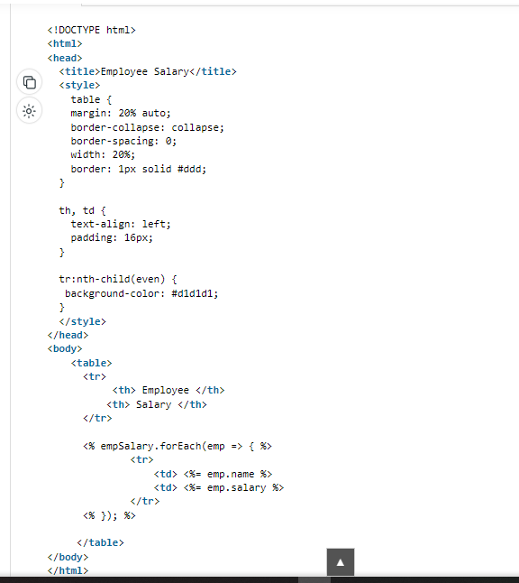

Figure EJS Page

# Express Application Generator

Use the application generator tool, express-generator, to quickly create an application skeleton.

ye hamain ek template pura structure provide krta ha banai banai application ka yani msln jb hum koi project bnaty hain tu usmy hamain roots ka aledha folder images ka aleda folder css ka aledha etc aisy krna prta ha lekin hum jb express generator application use krty tu ismy automatically hamain bany banay pury structure ka sath ye sary folder mil jaty jismy hamain khud banany ki ziada zarort nhi prti aledha sa folders hr cheze ka liay. The Express Application Generator allows you to create a project that is configured to use the most common CSS stylesheet engines: LESS, SASS, Compass, Stylus.

To install express application generator globally: type this in cmd

npm install -g express-generator

To create application just type this in cmd:

express --view=pug myapp

view ma humny pug dia ha tu index.pub aisi files hon gi lekin hum koi aur template engine bhi da skty msln ejs etc. aur usky bad application name dena ha msln yahan myapp dia howa ha.Isky bad hamain npm initiate krna ha kionky jb bhi hum koi folder banaty hain tu hamain manual khud krna prta ha **npm install** cmd ma likh kr taky package.json file ban jay aur hum server kr sakain run.Isky bad hamain teminal pr likhna ha

$env:DEBUG='myapp:*'; npm start

Ye environment set kr da ga aur automatically server run bhi kr da ga.Just to see the output we can go to http://localhost:3000/  on browser.

Ek dfa ye kr dain tu hum simple nodemon bhi use kr skty msln nodemon index.js taky bar bary na krna pry run after making some changes.

**Routing**

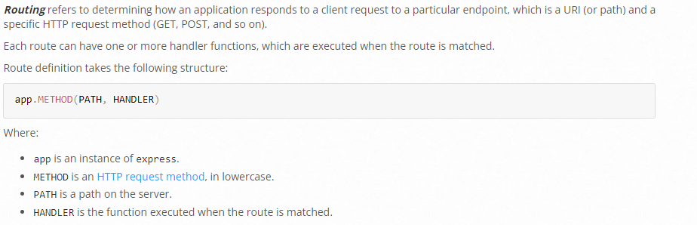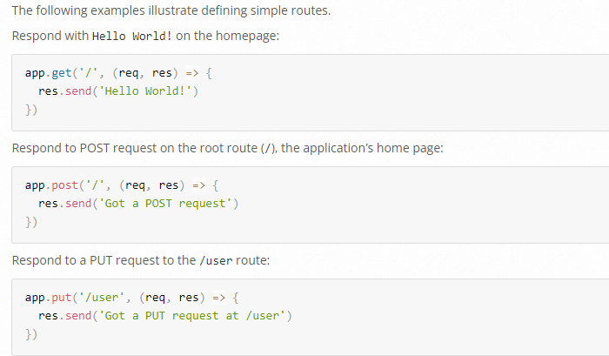

Yani url ma ye endpoint ho gat u ye response show krwana ha ya ye wala page isko routing kehty hain.khali ‘/’ ka mtlb rootmain directory ha.

# How to use Static Files in Express

Hamari application ma html,css,images etc files hoti hain ye sb static files hoti hain inko hum ek aledha sa public folder bana kr usmy dal dety hain.Msln hum ek separate folder public ka nam sa bana dety hain jisky andr images,html files,css files ka folders bana dety hain taky files apny shi folder ma hon aur ye sari static files ko access krny ka liay hamain sirf public folder ko hi use krna pry.

Note: hum static files ko apni appications ma directly use nahi kr skty hain.Msln

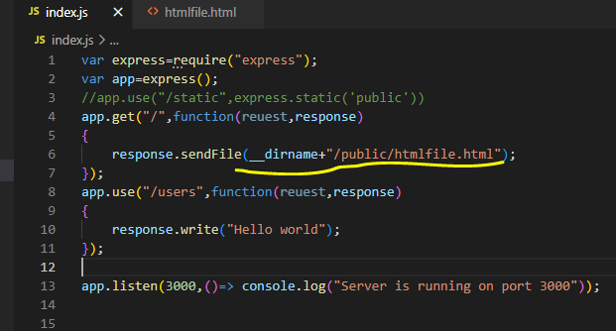

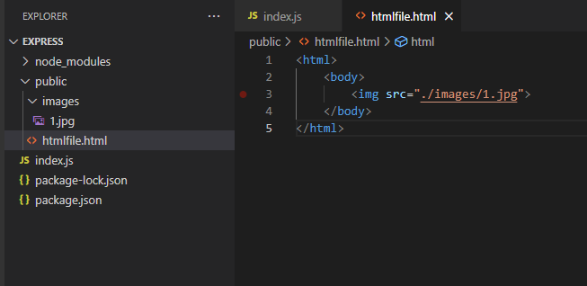

**Output**



**Solution:**

Express ma hum directly static files ko nahi kr skty hain use is liay hamain express ma static files ko use krny sa pehly unhain apni application ma define krna prta ha.

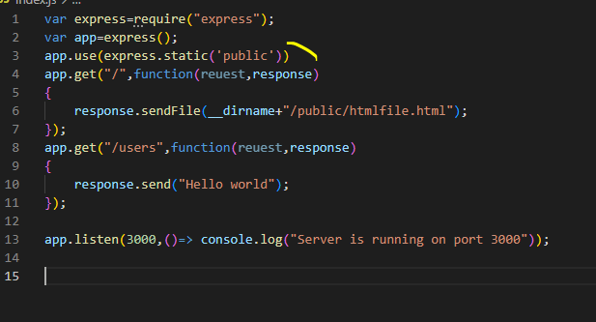

Output:



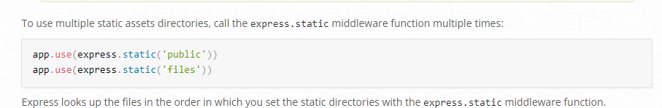

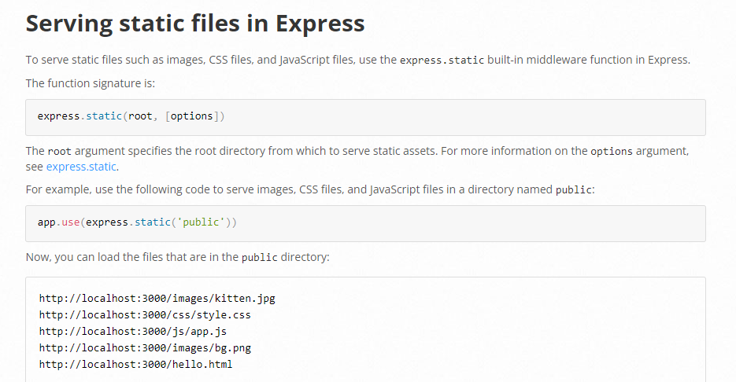



**Important Point regarding security**

Ab agr koi is image pr right click krky new tab ma open kry tu url ma address a jay ga ka kis folder ma ye image pri ha ya koi is image pr right click krky inspect ma ja ka src ma dekh skta ha ka kahan pri ha ye file aur hacking chances bhar skty hain.So to avoid this we just have to give virtual directory path in the first argument of app.use() aur wohi dikhy ga user ko bhi url ma aur usko lgy ga ka file is folder ma ha jbky wo fake virtual directory ka nam a raha ho ga url ma.

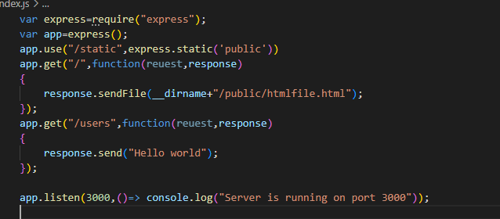

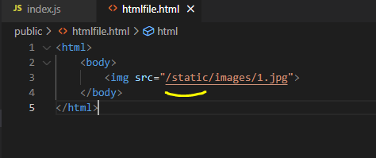

Ab humny app.use() ma 1st argument ma /static likha ha yani ek virtual non existing directory ka nam da dia ha aur ab hr jagha hamain src dety wqt yehi pehly likhna ho ga taky user ko output ma is non existing virtual directory ka nam show ho aur wo samjhy ka ye fil is directory ma pri ha jbky ye directory tu exist hi nhi krti.Hum koi aur nam bhi da skty hain instead of this /static.Kionky asam tu humny likh dia define kr dia ha ka express.static(“public”) yani all public files is folder sa lo tu hum koi bhi nam dain 1st argument ma frk ni prta.

Output: 

# Create Route with Parameters using Express js

Example1:

Agr endpoint /users ho



Output: 

Examle2:

Agr endpoint /users/Ali h tu

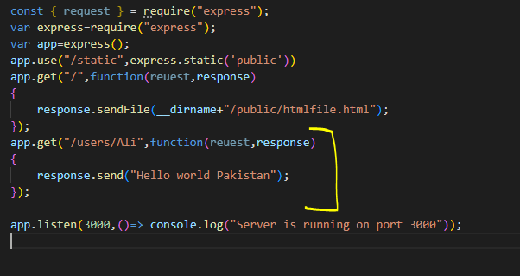

Output



**Example3: Passing compulsory parameters**

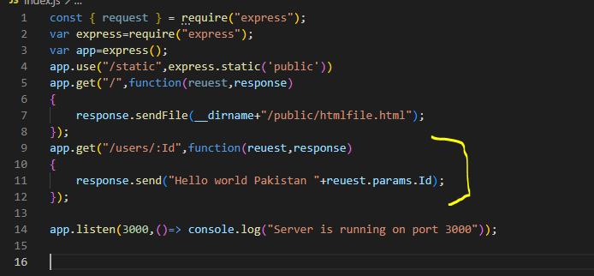

Output1:



Output2:



Hum compulsory parameters pass kr skty hain msln ab agr hum url ma endpoint ma parameter nhi dety tu error ayy ga

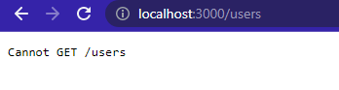

Is liay hum parameter ko optional krny ka liay agy ? uestion mark laga dety hain ka parameter do y ana do is endpoint ka liay work kry routing yani.Basically hum kr bhirequest rahy hain ka is parameter ka regarding output dikhao isi liay request ka variable hi use howa ha yani user na jis parameter ka liay ask kia ha

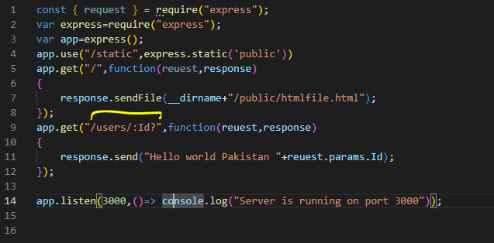

Output:





Humny parameter ma question mark end pr laga dia jiska mtlb ha ka optional ha ye parameter yani do ya na do koi restriction ni ha.

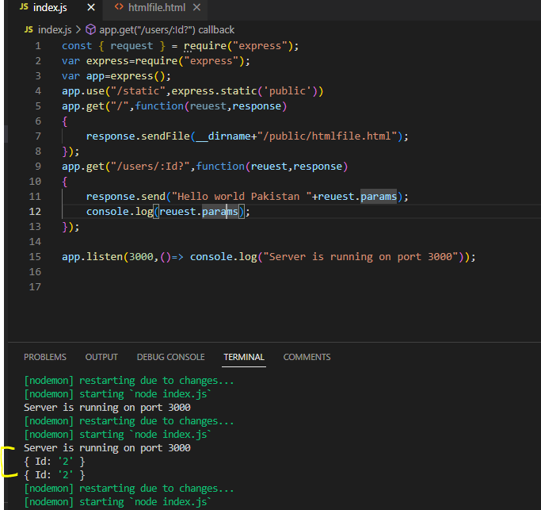

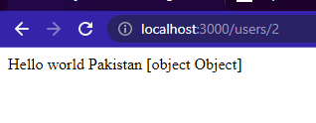Broswer ma object is liay aya kionky hum object ki waja aisy direct nhi print krwa skty lekin console ma krwa skty hain.

<https://expressjs.com/en/guide/routing.html>

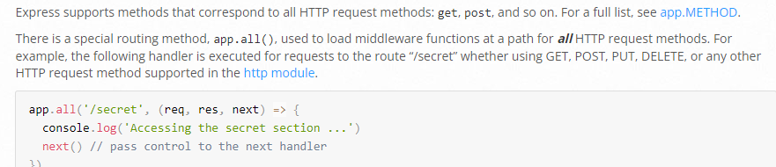

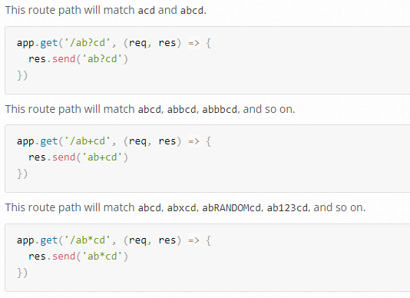

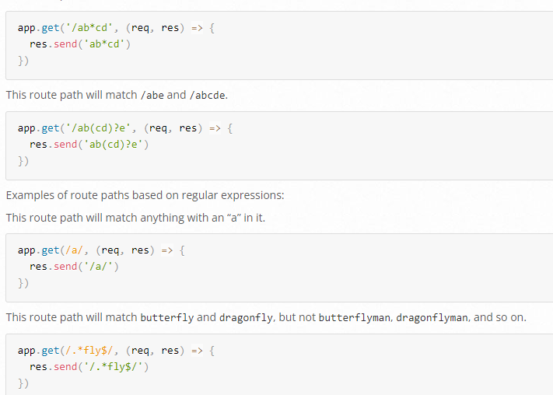

**Writing middleware for use in Express apps**

**It is a piece of code that comes in the middle of request and response . It kind of hijacks your request so that you can do anything that you want with your request or response eg: Modify the data or call the next middleware.**

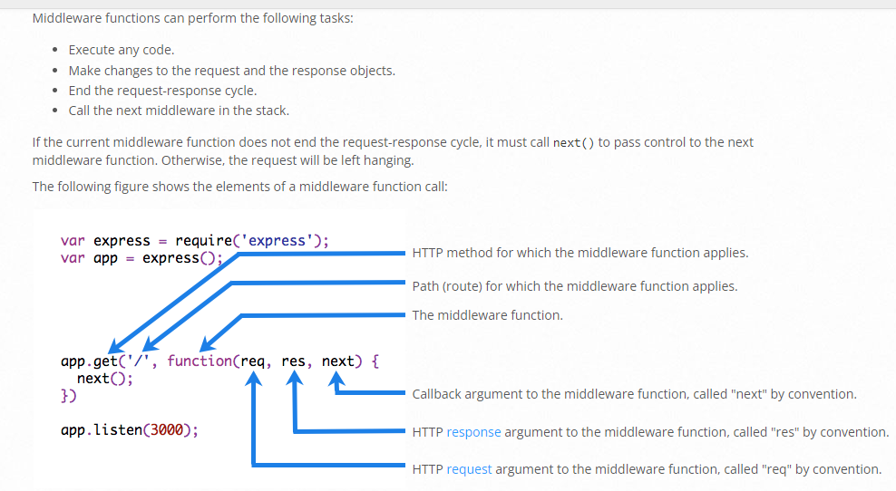

**What is next () in node JS?**

**Answer:** The next() function is not a part of the Node. js or Express API, but is the third argument that is passed to the middleware function. The next() function could be named anything, but by convention it is always named “next” 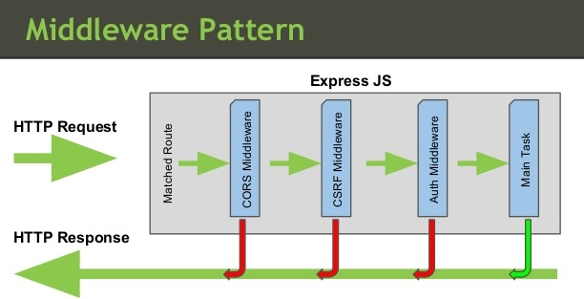

Request aur response ka drmian ma middleware hoti ha.

Middleware server aur client ka drmian ma hum lagaty hain jo msln as security ka kam kry ga jismy hum apni validations etc lga skty hain.aur agr validations thek sa verify ho jati satisfy tb next() use krty hain jismy hum redirect krwa skty hain kisi aur page pr.Msln user na koi page access krna ha tu pehly middleware ma dekha jay ga ka wo loggedin ha? Agr yes tu next() point pr jay aur next point next middleware pr aya tu hum wahan dekhain ka kia user ka role=? Ha agr tu user wo access krny ka aehl ha ya nahi? Agr nhi tu agli middleware pr nhi jay ga control aur agr han tu next().

**Global middleware**

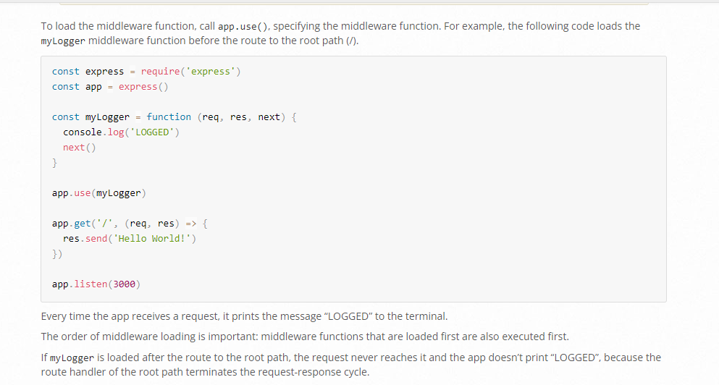

**Example**

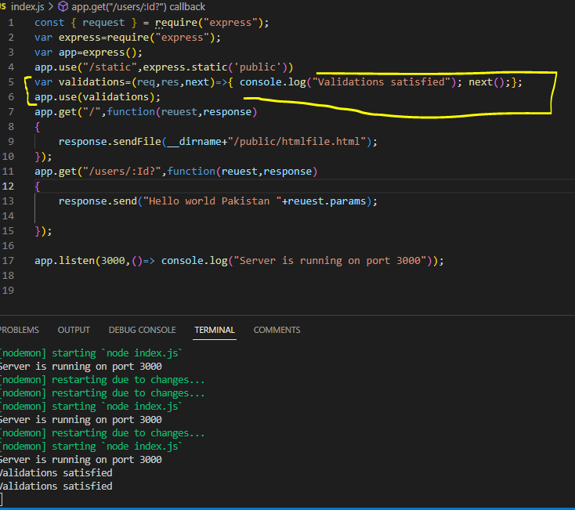

Output:

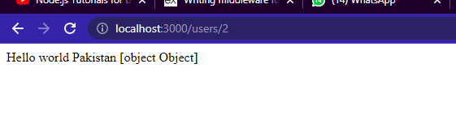

App.use(MiddlewareFunctionName); ye line jb hum kisi bhi route ka bahir likhty hian jaisy is auper waly program ma likhi hoi ha tu wo global middleware ban jati ha yani tamam requests ka against ye middleware work kry gi call ho gi.yani jb bhi hum koi request krain server sa msln ab localhost:3000 likhain tu global middleware call ho gi aur usky andr wali console wali line ho gi execute aur next() ka mtlb ka satisfy ab agly point pr ja skty hain.agr hum ab localhost:3000/users/param krain tub hi call ho gi global middleware .Yani tamam requests ka liay ye global middleware work kry gi call ho gi.

**Middleware for Particular Request**

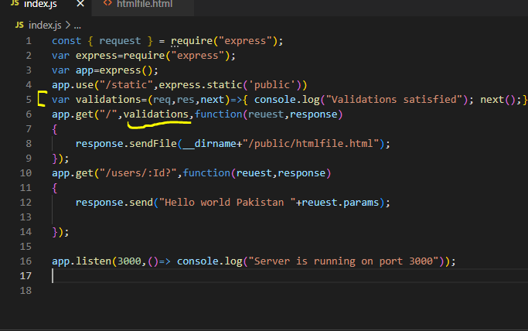

Yani humny particulary ek request ka against middleware bana di ka is request ka against ye middleware kam kry aura gr user ye request kry msln ab localhost:3000 kry tu pehly middleware execute ho gi aura gr wo satisfy tu usky andr next() ki waja sa next point pr jay wrna nahi.Ye middleware ko agr hum jis bhi request ka against execute krwana chahty hum kr skty hain hamain sirf jis bhi request ka against krna ha call hum usky 2nd parameter ma isko likhain ga jaisy root/main directory request ka liay is middleware ko use kia ha.

**Passing parameters to middleware**

Middleware ka request argument ma automatically a jaty hain values jinki request ki gai ho

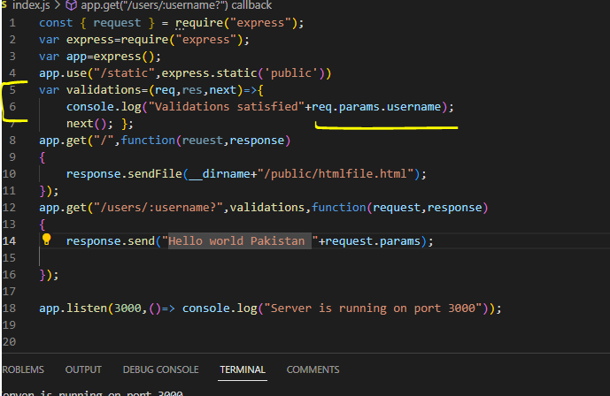

Note: Agr hum next() nhi likhain gat u kabhi bhi browse stop nhi ho ga aur sirf chalta ghomta rahy ga gol gol kionky next point kahan move krna ha nai pta flow of control ma.is liay redirection next point kahan move krna uska pta chaly is liay hum use krty hain next();

**Using template engines with Express**

Humain jonsa bhi template engine use krna ha pehly hamain usko install krna pry ga msln humny ejs template engine use krna ha tu hamainn **npm install ejs** krky install krna ho ga usky bad hamain apni js file ma thora define krna ho ga ka hum is template engine ko use krny lagay hain .Aur normally hum jb without template engines ka bagair kam kr rahy thy tb hum sendfile ya send krty thy lekin ab hamain render() use krna ho ga.

There are lots of template enginers i.e pub , ejs <%= %> , twig {{}} etc

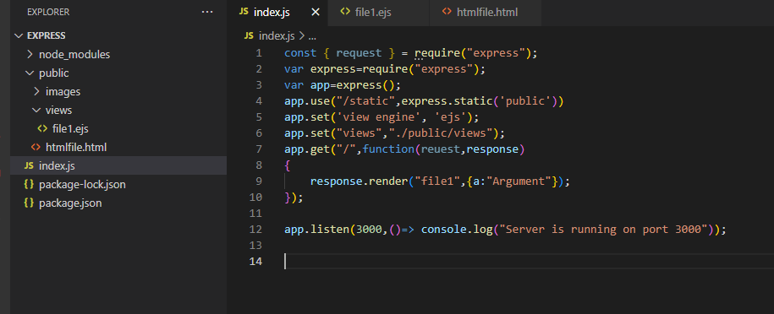

* Line5 ma humny bataya ha ka hum ejs view engine use krny lagain hain.Humny jonsa bhi engine use krna ha hamain uska nam 2nd argument ma dena ho ga.
* Line6 ma humny bataya ka views tamam is jagha milain ga taky hamain bar bar na likhna pry address pura pura ka public/views/index.ejs etc iski baajy hamain sif index likhna pry ga isky liay humny pehly hi define kr dia ka views tama yahan milain ga.Ab is line ki waja sa humny line9 ma render krty wqt bhi file name ma without extention sirf file ka nam dia ha.Yani ye plus point ha ka bar bar lamby lamby src/address deny ki bajay ab humain sirf address dety howy us particular file ka nam dena ho ga.
* Render() ka andr 1st argument ma humain file name likhna hota ha jisko render krna ha aur dusry argument ma hum arguments bhejty hain as an object
* **Note: Template engines ka sath kam krty howay hum render likhty hain kionky humny views render krwany hoty hain.**

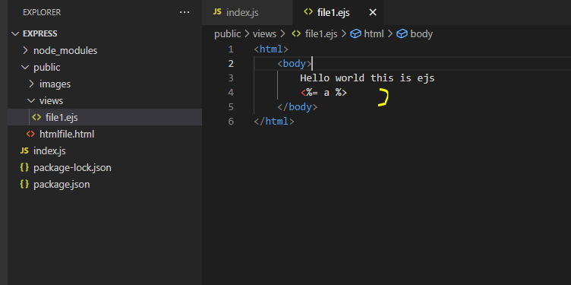Ejs ka syntax html sa kafi milta julta ha bs ismy dynamic variables etc ko likhny ka liay hamain

<% %> use krna prta ha.

Output:

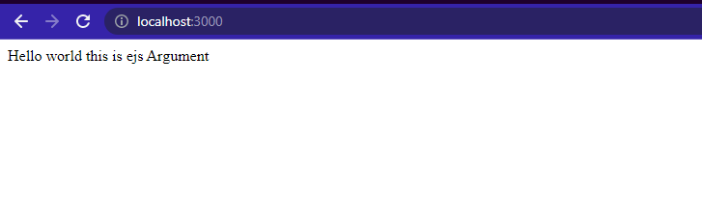

# How to handle get and parse post request in express.js | body parsing middleware

Post ma hamary pas response ka andr data ata ha aur wo bhi response ki body ka andr.

Given eample ma humny ek form sa data post kia ha aur us page ka andr form ka fields ki values pkr kr dusry page pr print krwai hain.Ab ek form sa values leny ka liay hamain body parser ka use bhi krna prra.

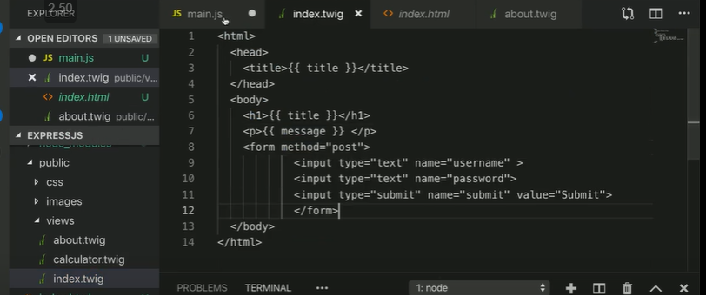

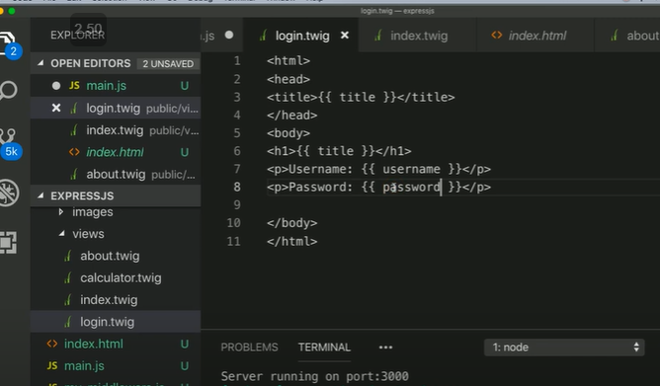

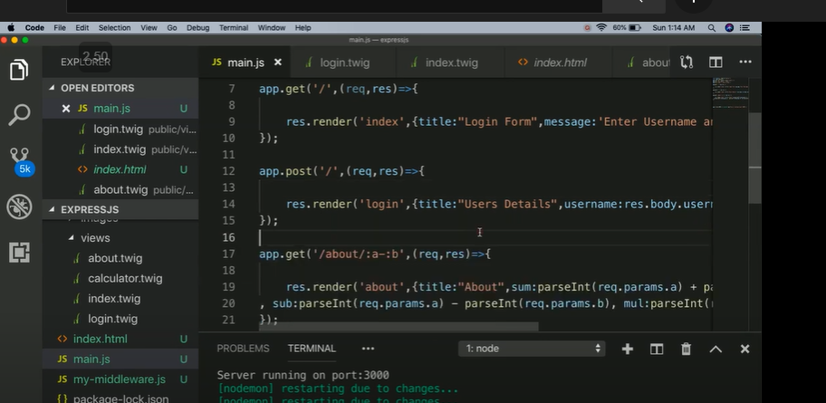

Lekin post ka liay humain ek aur module use krna prta ha kionky hamain body parser ki zarort ha jisky liay hamain isko install krna ho ga

npm install body-parser

aur phr ye 2 lines apny code ma likhni hon gi.

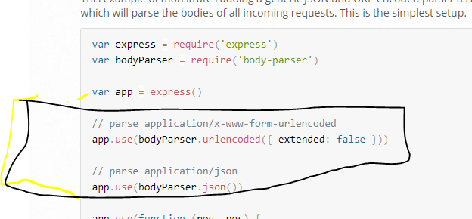

Figure ye data ko url sa la kr usko json format ma convert kr da ga

# Form validation using express validator in express.js | use of express-validator package

**MongoDB**

MongoDB is an open source NoSQL database management program. NoSQL is used as an alternative to traditional relational databases. NoSQL databases are quite useful for working with large sets of distributed data. MongoDB is a tool that can manage document-oriented information, store or retrieve information. **MongoDB is a source-available cross-platform document-oriented database program.** Classified as a NoSQL database program, MongoDB uses JSON-like documents with optional schemas. MongoDB is a schema-less NoSQL document database. It means you can store JSON documents in it, and the structure of these documents can vary as it is not enforced like SQL databases. This is one of the advantages of using NoSQL as it speeds up application development and reduces the complexity of deployments.

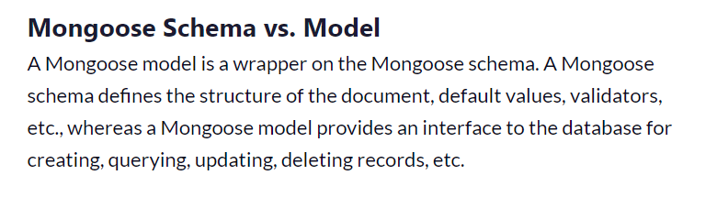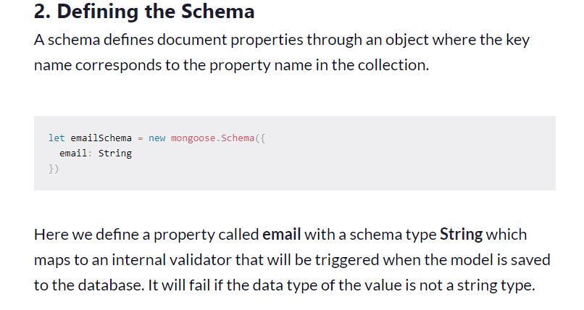

**https://www.freecodecamp.org/news/introduction-to-mongoose-for-mongodb-d2a7aa593c57/**

[**https://mongoosejs.com/docs/**](https://mongoosejs.com/docs/)

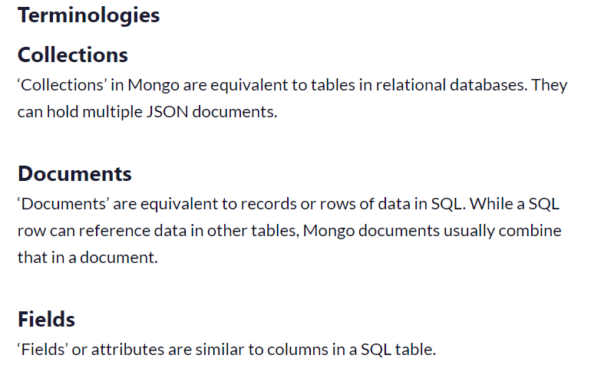

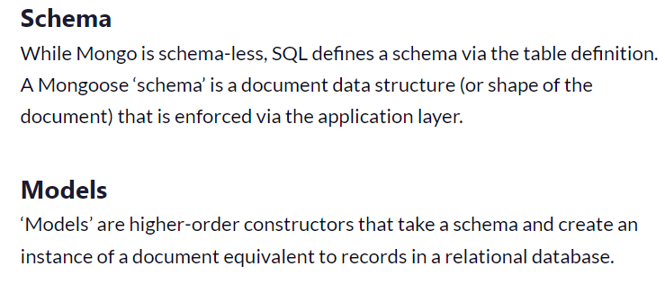

**Schema ma hum apny table(collection) ka structure bataty hain ka ye ye column ho ga aur is column ki ye data type ho gi ya ye wala column null values accept kr skta etc.Jbky Document are like rows in collection(Table).**

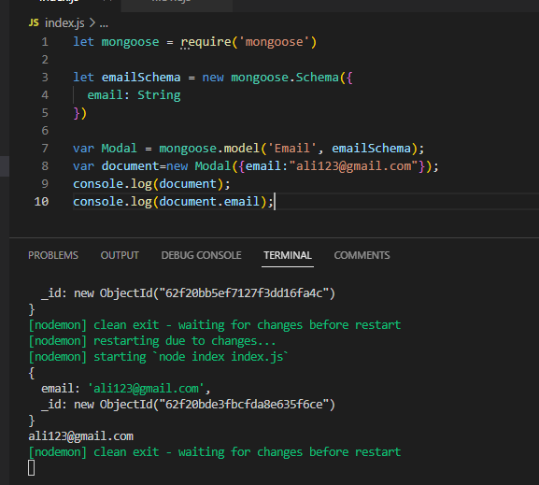

* Line1 ma humny mongoose ko require kr lia taky uski inner functionalities access kr sakain.
* Line3 ma humny schema define kia ha yani jaisy sql ka table ki hum setting krty hain ka is column ki data type ye ho gi ya ye wala column null ho skta ha ya ye wala default ma iski value ye set ho gi etc usi trha hum nosql ma schema define krty hain ka is field(column) ki datatype ye ho gi ya ye null ho skta etc.
* Line7 ma humny Table(Collection) banaya ha basically modal.Yani humny 1st argument ma nam dia ha scheme ka aur dusry argument nam dia ha collection(table) ka ka is nam ka modal/table/collection bana do.
* **Note: By default jb bhi hum koi new document(row) banaty hain Mongo db ma tu us document ma ek unique id ka field add ho jata ha.Jisy humain explicitly koi primary key ka liay separate column nhi banana prta by default hi hamain ye mil jata ha column.**
* Line8 ma humny document banaya hayani record/row/document ka is table ka humny basically object banaya jisky andr humny values pass kr di ka ye is table/modal/collection ma insert kr do.

**MLab**

It is a live database. mLab is a fully managed cloud database service that hosts MongoDB databases. mLab runs on cloud providers Amazon, Google, and Microsoft Azure, and has partnered with platform-as-a-service providers.Jaisy php ma myadmin hota ha waisy hi mlab bhi ek live database ha jo specifically mongosedb manager ha aur ispr humain 5mb ki space milti ha only.

**MongoDb Server**

Ismy hamain sirf data dikhta ha lekin separate ziada features nhi

**MongoDb Compass**

Ismy humain collections+data show create add etc zary options mil jaty hain yani wahien sa new collection create krky andr data crud bhi kr skty wahien hi.isy humain Gui provide kia jata ha

**MongoDb Shell**

Hum apny cmd ka through operations perform kr skty han yani cmd sa database create collections data etc sb manage kr skty hain.Yani cmd pr cmmands ka through agr hu mongdb ko handle mange krna chahty hain tu hamain mongodb shell download krna pry ga

**MongoDB installation**

<https://www.youtube.com/watch?v=yiz5bmLVVhs&t=861s>

**Install MongoDB Shell Mongosh on windows**

<https://www.youtube.com/watch?v=NtiHLL-8iiU>

Yani agr hum chahty hain ka mongodb ko cmd sab hi manage kr sakain yani cmd pr commands sa collections bana lain document databases etc bana lain tu usky liay hamain mongodb shell download krna ho ga.

Agr hum chahty hain ka bar bar hamain lambi lambi staments cmd pr na lkhni prin yani bin ka andr wala ja kr md pr na likhna pry tu tb bhi hum environmental variable set kr dety hain taky cmd sa shell mongodb access krny ka liay hamain sirf mond aur mongosh likhna pry

**MongoDB Compass**

First of all we have to install mongodb compass in our local computer.Hamain mongodb compass download likhna ha aur msi select krna ha then download install and next next.Compass ka benefit ye ha ka ye hamain cmd shell ka bhi access free da deta yani hamain aledha sa mongodb shell download krny ki zarort nahi ha hum gui+cmd/cli donon ka through access kr skty hain mongodb ko.

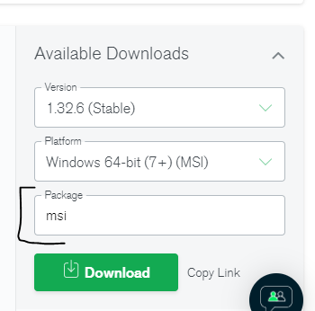

Error on cmd : [**.mongo' is not recognized as an internal or external command, operable program or batch file**](https://stackoverflow.com/questions/51224959/mongo-is-not-recognized-as-an-internal-or-external-command-operable-program-o)

Soluti Solution : set environment variable.

**Lookups**

Jaisy sql ma left joins hoty hain mongodb ma lookups hoty hain.The MongoDB Lookup operator, by definition, “**Performs a left outer join to an unshared collection in the same database to filter in documents from the “joined” collection for processing.**” Simply put, using the **MongoDB Lookup** operator makes it possible to merge data from the document you are running a query on and the document you want the data from.

<https://hevodata.com/learn/mongodb-lookup/>

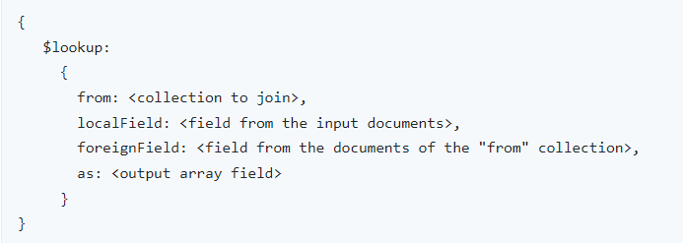

From ma hum dusry table(collection) ka nam dety hain.

localField ma hum us field ka nam dety hain jo first collection(table) ki ha

foreignField ma hum dusry table(collection) ki field ka nam dety hain jisky sath match krna ha

as ma hum koi bhi mrzi ka nam dety hain jismy likha ayy ga ka ye current wala record dusry table(collection) ka is record sa match krta ha

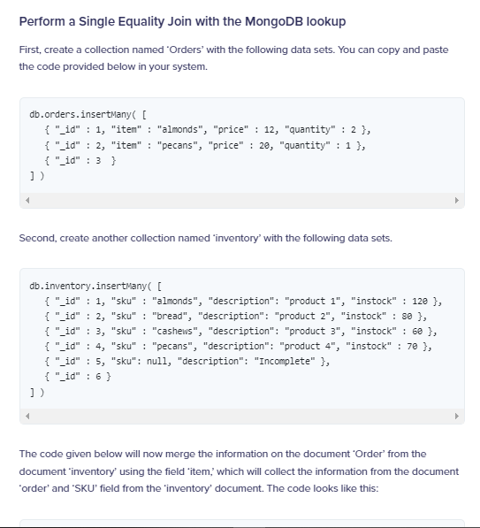

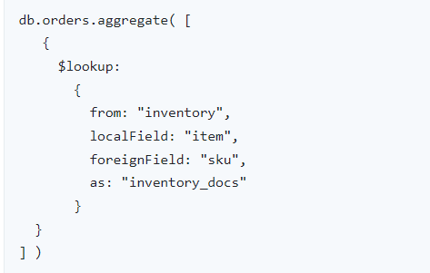 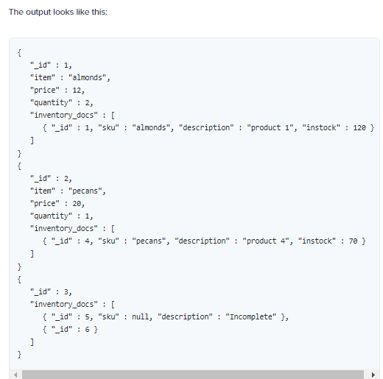

**Sort**

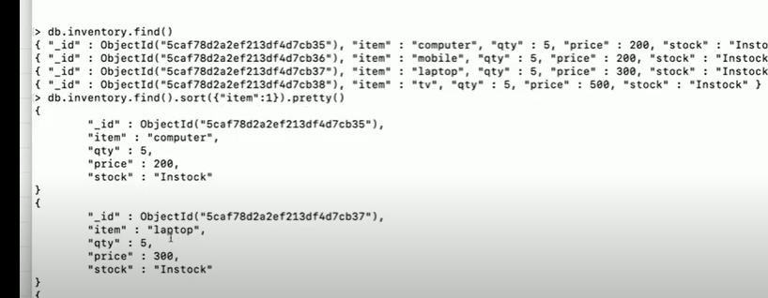

Ascending sort ka liay hu 1 dain ga aur descending sort ka liay -1.

Pipelining:find() ka agy humny sort() aur usky agy pretty() lagaya ha isko chaining/pipelining kehty hain

**Skip()**

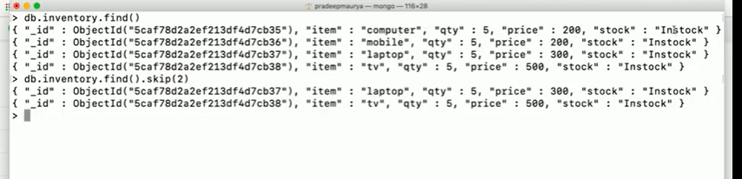

Agr hum chahty hain ka start say ya end sa kuch rows skipp krain tu skip() use krty hain.Top sa skip krni ha tu +ve value.

**Limit()**

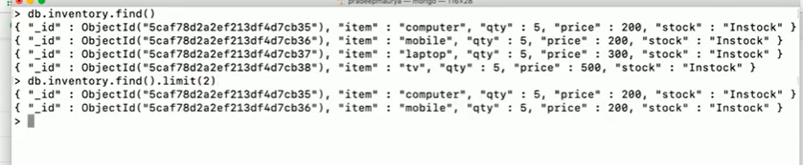

Limit() ma hum bataty hain ka itny no of records just chahiay msln 5 records hain unmy name jan same ha aur hum chahty hain ka sirf 2 unmy sa dikhay jaien tu hum limit(2) lagaien ga

**Indexing**

Why Indexing is used in database?

Answer: An index is a schema object that contains an entry for each value that appears in the indexed column(s) of the table or cluster and provides direct, fast access to rows. The users cannot see the indexes, they are just used to speed up searches/queries.**Indexing sa searching fast ho jati ha.** Indexing is a way to optimize the performance of a database by minimizing the number of disk accesses required when a query is processed. It is a data structure technique which is used to quickly locate and access the data in a database.

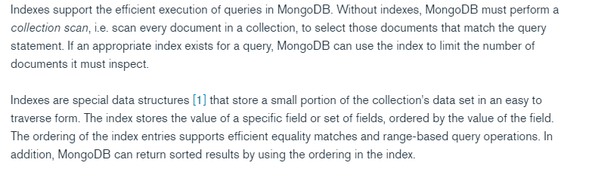

MongoDB indexes use a B-tree data structure.

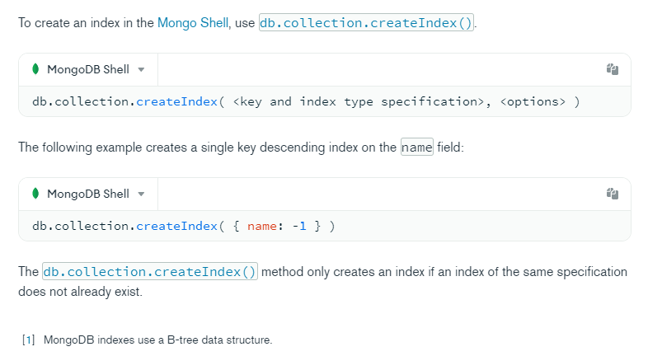

Hamain jis field ko as indexing create krna ha hum us field ka nam db.CollectionName.createIndex() ka andr dety hain.

# Schema Validation

MongoDB provides the capability to perform schema validation during updates and insertions.MongoDB has a feature called schema validation that allows you to apply constraints on your documents' structure. Schema validation is built around JSON Schema, an open standard for JSON document structure description and validation

# Mongoose Insert Document

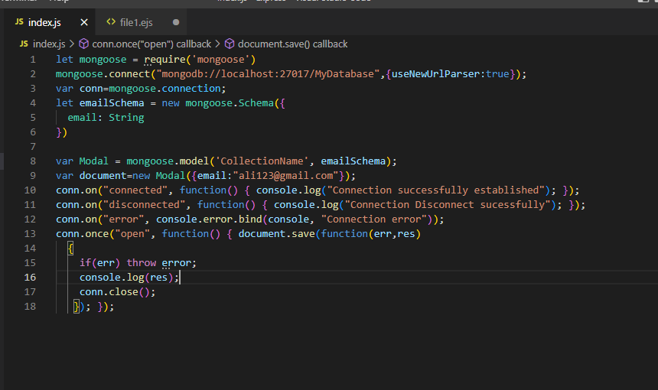

Line1: sbsy pehly humny mongoose ko require kr lia taky inner functionalities uski import ho jaien.

Line2:Humny connection local db ka sath establid kr lia jisky end pr humny apny database ka nam dia.Agr is nam ka database already ho ga tu usi ka sath ho jay ga connection establish otherwise new database is nam sa create ho jay ga.

Line3: hamain ab connection ka object banana ho ga taky hum us object ko use krty howay crud etc perform kr sakain ar deal kr sakain us database ka sath.

Line4:Humny scheme banaya ka database ma is format ma ho ga data aur line 8 ma model banaya aur line 9 ma class ka object type banaya jismy values dien jo insert krni us modal(collection) ma.

Line10:humny connection ka object ka through dekha ka agr connection successfully establid ho gya ha tu ye execute ho .waisy tu tamam code is functonka andr rakhna chahiay taky agr connection successfully establish ho tb hi ye execute ho iski inner body.

Line11:Jb connection disconnect ho gat u ye execute ho ga.

Line12:agr connection establish hot wqt koi bhi msla a gya aur connection establish nhi ho paya tu ye wala line eecute ho gi.

Line13: humny document insert kia ha collection ma

Important Point

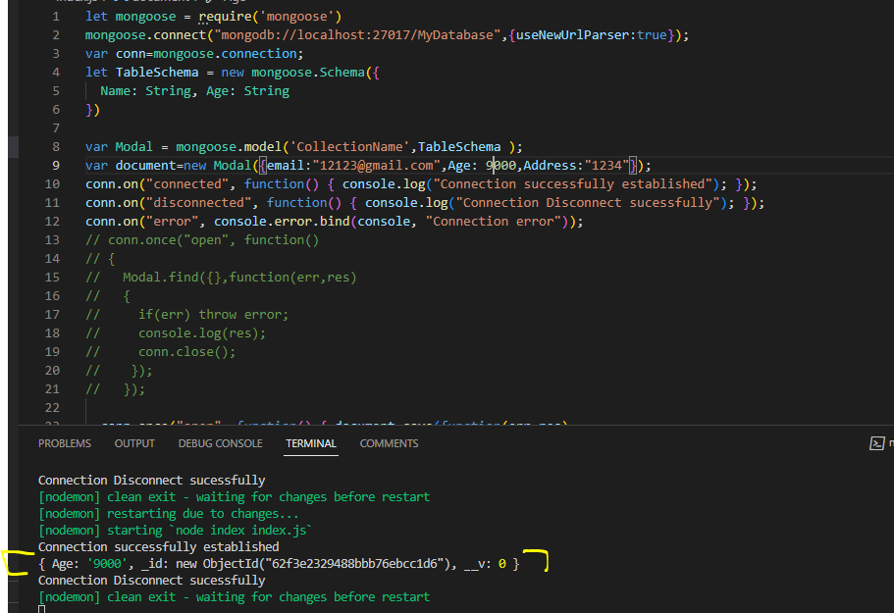

Ab kionky schema ma nahi tha email aur address tu is waja sa wo ignore hoi aur database ma sirf Age insert howa kionky is modal object ma ek Age hi tha jo schema ko follow kr raha tha.

**Read from Collection**

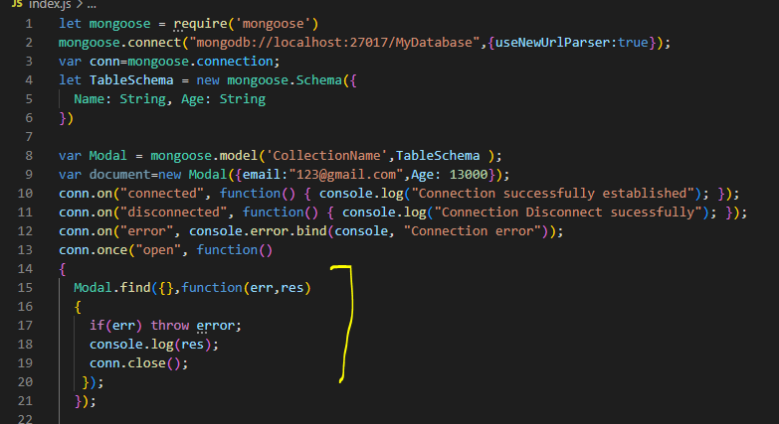

Database sa data read krty wqt hum modal use krty hain.Modal ma hamain batana prta ka is database ma data is scheme ka mutabik pra howa.

* Find() all records(documents) retrieve kry ga.Kionky ye all records return krta ha tu ye ek array return krta ha jismy objects yani different documents(records) hoty hain.

1. Hum kisi specific field sab hi search kr skty hain msln agr hamary collection(table) ma different fields(columns) hain aur hum chahty hain ka name column ma agr ye nam mily tu wo wala record(document) return kro tu

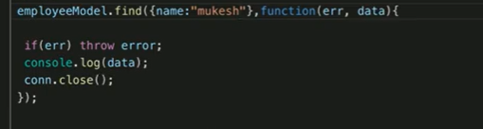

* findOne() sirf pehla document(row) pkry ga collection(table) sa.Ye ek object return krta ha kionky ismy sirf ek hi document retrieve kia jata ha.
* findByid() sirf matching id waly document ko return kry ga

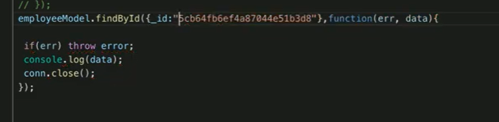

**Update Operation**

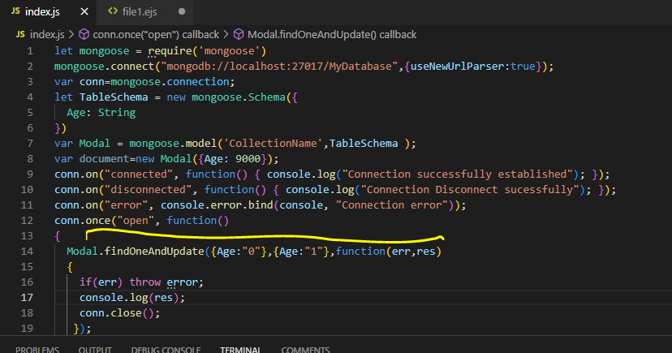

Yani jo bhi isko matching records(document) milain ga unmy sa ye sirf pehly ma updation kry ga.

**Delete Operation**

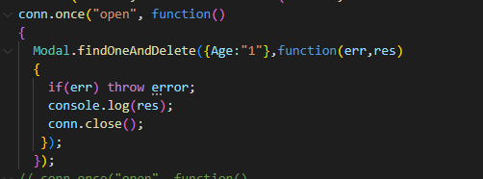

Ye matching value waly document ko delete kr da ga.

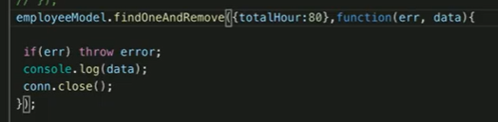

Hum ek modules ka folder bana kr usmy say modules bana lety hain jimmy schema hota ha hamary aur toots folder ma index.js file ma module ko export kr lia